Create a simple script file and push it to repo. Create a project in Jenkins connected to your GitHub repository. When a commit is made to your repo, automatically build must get triggered from Jenkins and the output must be shared to me via email.

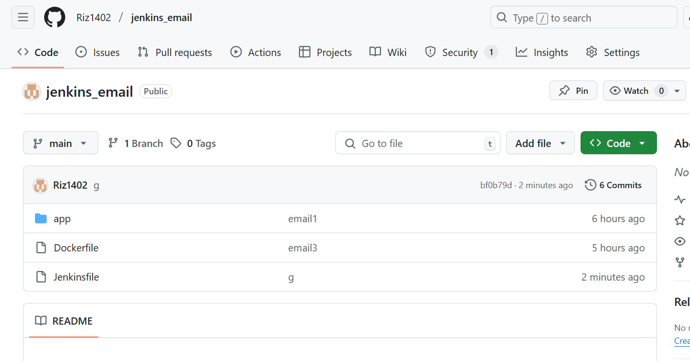

Jenkins file configuration for email

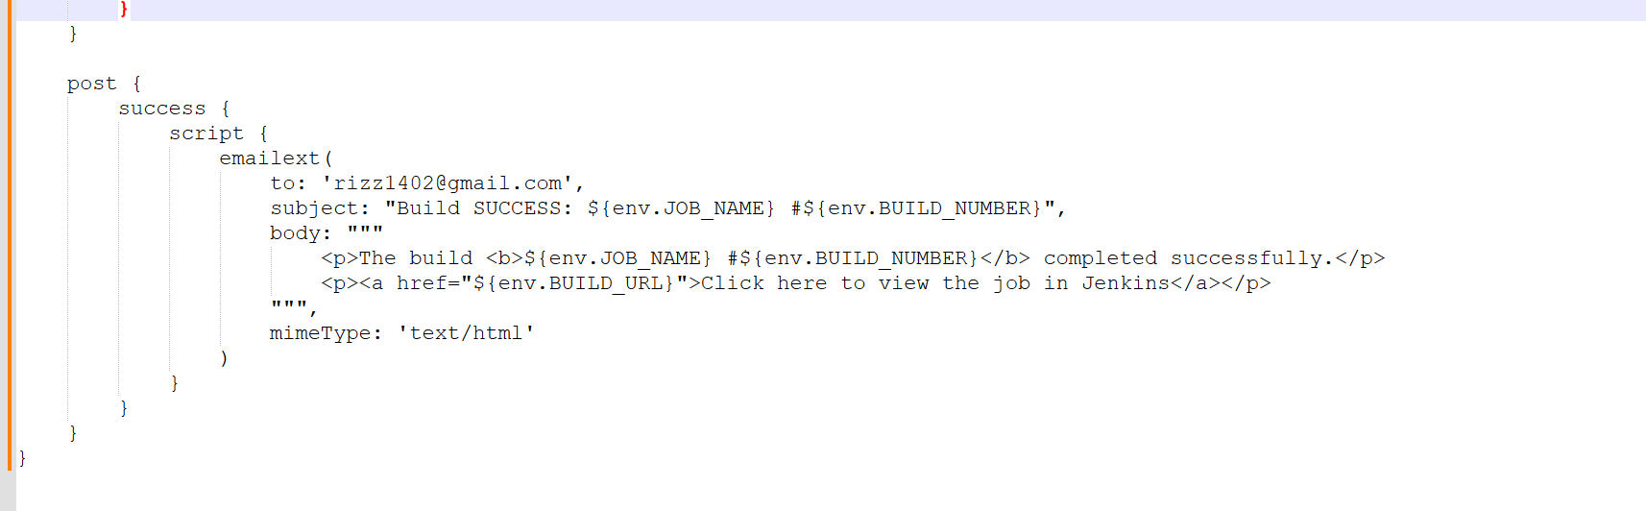

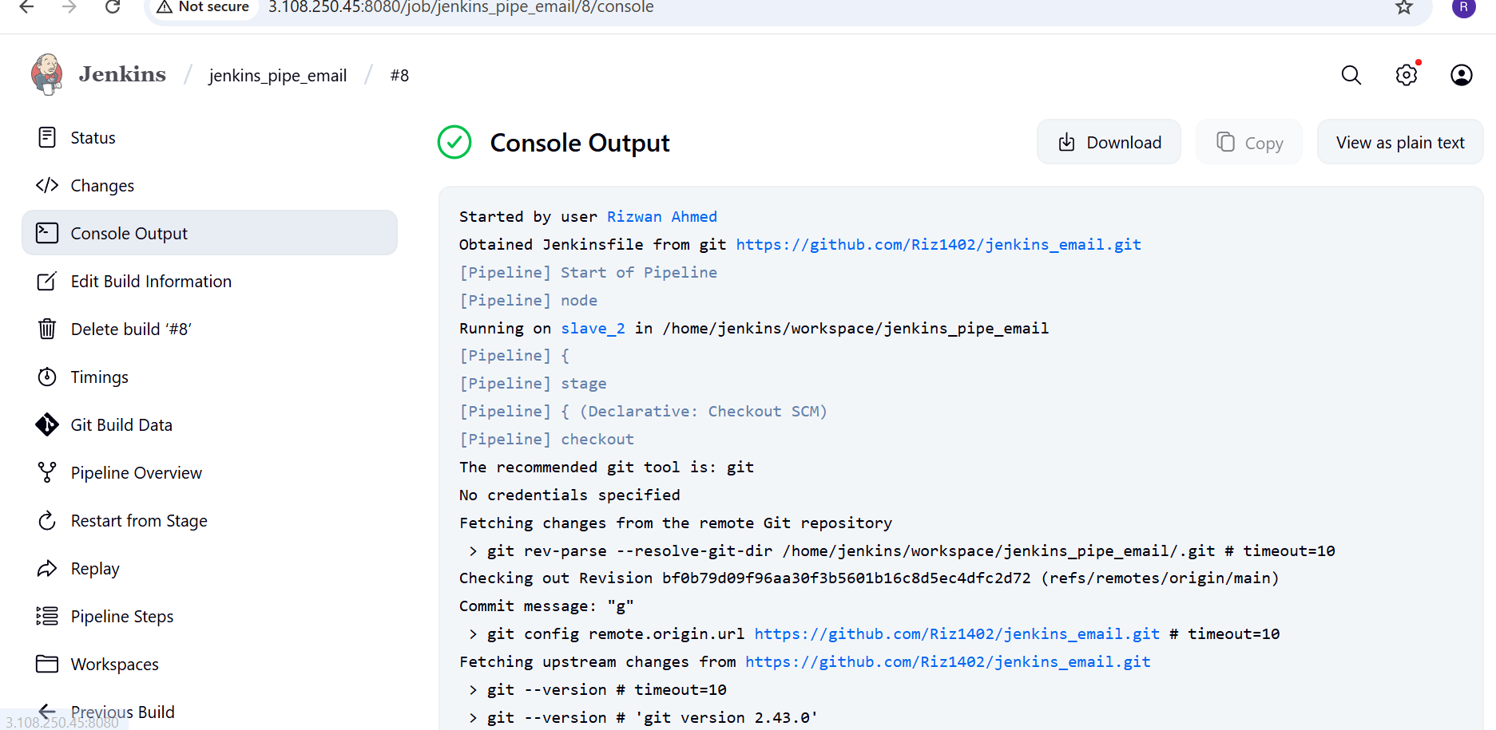

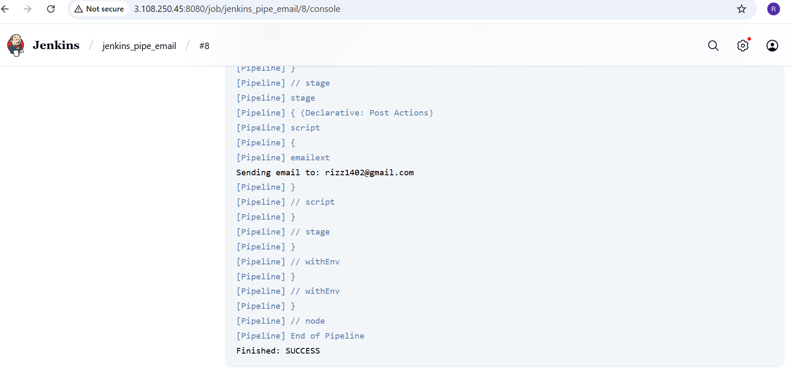

Email notification

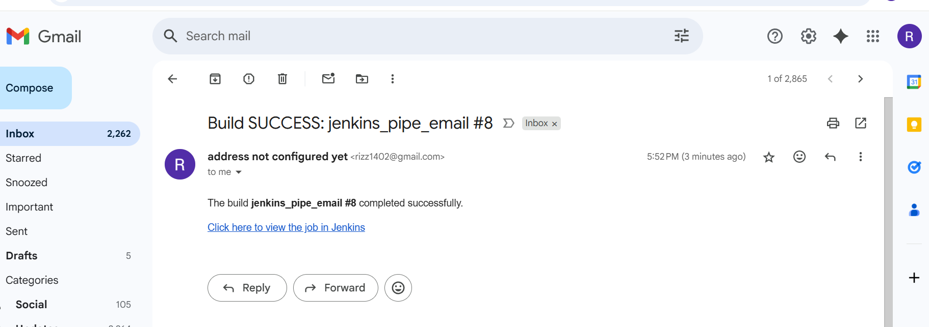

Application

